2024 Australian Paralympic Team Policies

## Concussion Management

### Introduction

Outside of Paralympic Games times, management of Sports Related Concussion (SRC) in Para athletes falls under the jurisdiction of the particular sporting federation that a Para athlete represents. The only exceptions to this are Wheelchair Rugby and Powerlifting which come under Paralympics Australia jurisdiction throughout the four-year Paralympic Cycle.

However, during the period of the Paralympic Games (summer and winter) management of SRC among members of the Australian Paralympic Team (APT) is the responsibility of the PA Headquarters Medical Team. This document articulates the Concussion Management Policy that will be applied by the HQ Medical Team during the Paralympic Games in Paris in 2024. The Policy will apply from 22nd August 2024, the Athlete Village opening date, until the APT returns to Australia on 11th September 2024.

### What is concussion?

### A concussion occurs through a collision with another person or object where biomechanical forces to the head, or anywhere on the body transmit an impulsive force to the head/brain, resulting in transient neurological impairment (AIS Concussion and Brain Health Statement 2023). Symptoms can include headache, blurred vision, impaired balance, memory loss, confusion, and diminished cognitive function. Onset of symptoms is typically rapid, and the condition often evolves over hours or days. Recovery times following concussion vary between athletes and can take days or weeks.

### Concussion Assessment for Para Athletes

### “The diagnosis of concussion is a clinical determination made by a Health Care Professional” (Patricios et al 2023). This statement is true for both able-bodied and Para athletes. Any athlete with suspected concussion should be REMOVED FROM PLAY, medically assessed, and monitored for injury related signs and symptoms, including deterioration of their clinical condition (Patricios et al, 2023). As part of the overall assessment an attending medical professional may choose to seek a corroborative history from suitable team members (eg coach) or carers, if available, to assist them in clinical decision making. It is important to acknowledge that some Para athletes have higher pre-injury SRC symptomatology related to their impairment.

### In the event that a Health Care Professional (HCP) is not present at a Paralympic training or competition venue where there is concern that an Australian Para athlete has sustained a Sport Related Concussion then the Concussion Recognition Tool 6 (CRT6) can be used (Echemendia et al, 2023; see Appendix 1 below). This is a ‘recognise and remove’ tool for non-medically trained persons, which can be used to identify suspected SRC at all ages and levels of activity, across a broad range of athletes from different sports, including Para athletes. Any athlete with a suspected concussion should immediately be removed from training/competition and not return until assessed by an HCP trained in concussion assessment. For Paris 2024 this assessment will be conducted by a member of the HQ Medical Team. The guiding principle here should be “If in doubt, sit them out” (AIS Concussion and Brain Health Position Statement 2023).

### Concussion Assessment for Para Athletes at Paris 2024

### Concussion in Australian Para athletes at Paris 2024 will, to the extent possible, be assessed, diagnosed, and managed according to the existing consensus guidelines that are applied for the able-bodied population. This will include utilization of a Sport Concussion Assessment Tool such as the SCAT6 (Echemendia et al 2023), although some components of this tool may require adaptation in accordance with the athlete’s particular impairment/s (Weiler et al 2021).

### In addition, APT HQ Medical Staff will have access to the “Cogstate Brief Battery”. This is a standardised on-line test of cognitive function that has been developed by Cognigram. There is a database of thousands of age-matched controls which often permits testing of athletes who have not had baseline testing prior to suffering a concussion (although athletes with visual impairments or intellectual disability may not be suitable for this type of testing). The Cogstate assessment will be administered by appropriately trained HQ doctors and physiotherapists using a laptop or tablet device.

### Key principles of SRC management in APT Para athletes at Paris 2024 will include the following:

### • **Recognize and remove:** once concussion is suspected the athlete should be removed from play or practice as detailed above

### • **Assessment:** by APT HQ Doctor if not on site at injury event location

### • (Notification of APT HQ Medical Staff: if athlete is a member of a team travelling with its own Federation doctor to Paris)

### • **Rest:** brief period of physical and cognitive rest (24-48h)

### • **Active rest:** gradual and progressive increase in activity while staying below their cognitive and physical exacerbation thresholds (activity should not worsen symptoms)

### • **Graded return to sport (GRTS):** as per figure 1 below. Each stage in the GRTS , highlighted in orange or green in figure 1, should be at least 24 hours and symptoms should return to baseline prior to progressing to the next stage. If symptoms do not return to baseline and are prolonged or severely exacerbated the athlete should not progress to the next stage. In these circumstances review by a member of the APT HQ Medical Team will be required.

### • **Reconsider and refer:** delayed progression through the GRTS because of persistent or recurrent symptoms may necessitate referral by HQ Medical Officers to specialist practitioners. Examples include physiotherapy for cervical spine or vestibular dysfunction, and cognitive behavioral therapy (CBT) for persistent mood or behavioural issues.

Figure 1: Graded return to sport framework (AIS Concussion and Brain Health Position Statement 2023)

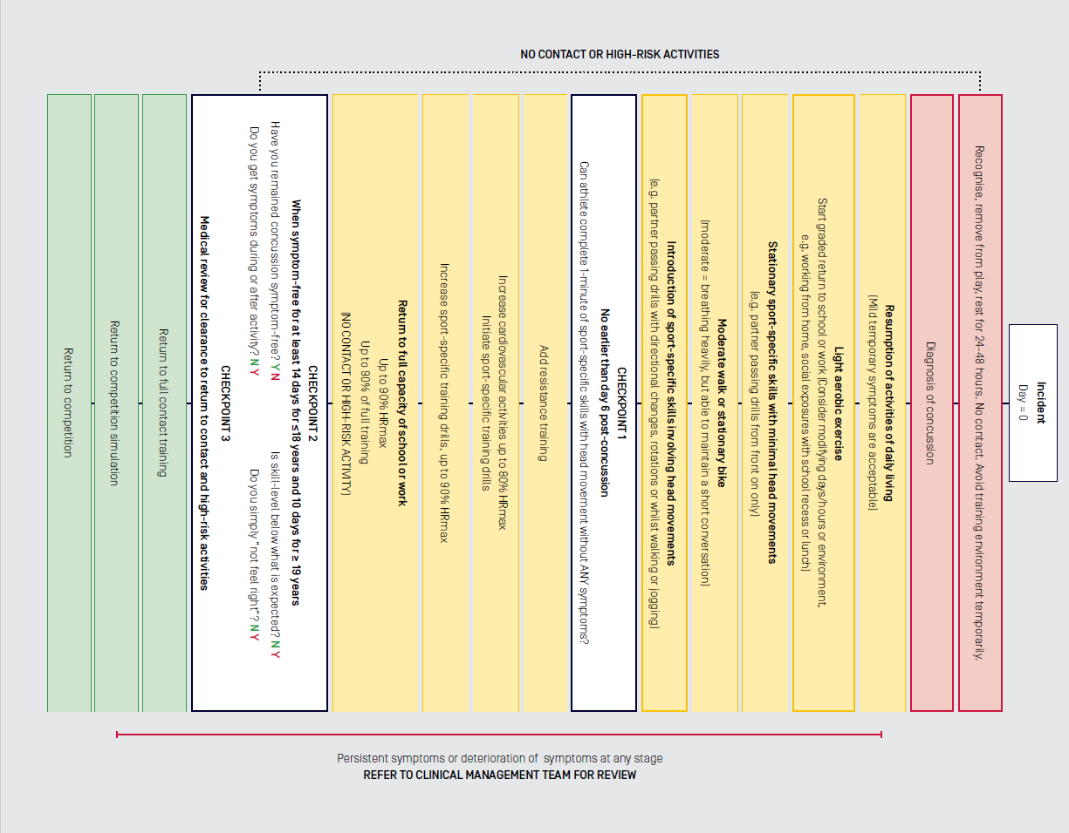

### Para Athlete Specific Considerations

### It is important for HCPs to be aware of the need to modify and refine concussion management depending on the unique nature of a Para athlete’s impairment/s (Weiler et al 2021):

### • **Recognize and remove:** Para athletes with intellectual impairment may have more difficulty understanding the need for removal from play

### • **Rest:** Wheelchair users may require additional assistance with chair propulsion, and with transfers, to avoid exacerbation of symptoms during the initial 24-48 hour rest period post-concussion

### • **Active rest and GRTS:** as the Para athlete begins to gradually increase their level of physical activity, the method for testing exercise threshold may require modification. For example, stationary cycling is often used as a submaximal exercise challenge, but this will not be suitable for wheelchair users. In this instance a hand cycle could be used as an alternative. Balance testing and testing of reaction time may also need to be adapted to accommodate relevant impairments.

### Concussion Handover

### If an athlete has suffered an SRC prior to joining the APT in Paris, then a comprehensive handover must be made to the APT HQ Medical Team. Similarly, the APT HQ Medical Team will provide a handover to an athlete’s sporting federation in the event that an episode of SRC is experienced during the Paralympic Games.

### In the event that a particular sport employs its own Team Doctor to care for athletes during the Paralympic Games in Paris then possible SRC cases need to be discussed with the APT CMO. This requirement is in recognition of the fact that all athletes on the APT come under Paralympics Australia jurisdiction for the duration of the Games.

### Conclusion

### Paralympics Australia needs to be prepared for the occurrence of SRC among members of the APT at the Paris 2024 Paralympic Games. While management of concussion in Para-athletes needs to be individualized, and decisions made on a case-by-case basis regarding return to sport, this policy has been written to articulate the principles that will guide the assessment and management of SRC among APT members during the period of the Games.

### References

Weiler R, Blauwet C, Clarke D et al. Concussion of para sport: the first position statement of the Concussion in Para Sport (CIPS) Group. Br J Sports Med 2021; 55: 1187-1195

AIS Concussion and Brain Health Position Statement 2023

Patricios JS, Schneider KJ, Dvorak J, et al. Consensus statement on concussion in sport: the 6th International Conference on Concussion in Sport - Amsterdam, October 2022. Br J Sports Med 2023; 57: 695–711

Echemendia RJ et al. Sport Concussion Assessment Tool 6 (SCAT6). British Journal of Sports Medicine 2023; 57: 622-631

Echemendia RJ, et al. CRT6. Concussion recognition tool to help identify concussion in children, adolescents and adults. Br J Sports Med June 2023; 57: 692-693

Appendix 1: Concussion Recognition Tool 6 (Echemendia et al, 2023)



