A Universal Design Guide for creating Inclusive
Sport in Australia

Universal Design Guide

Picture of the Paralympics Australia ‘Celebration’ graphic. Details within.

Produced by Paralympics Australia with input from a diverse range of people working and competing in different sporting codes.
Image Description
Paralympic skier, Rae Anderson, competes in the B22 D8 Women’s Slalom.
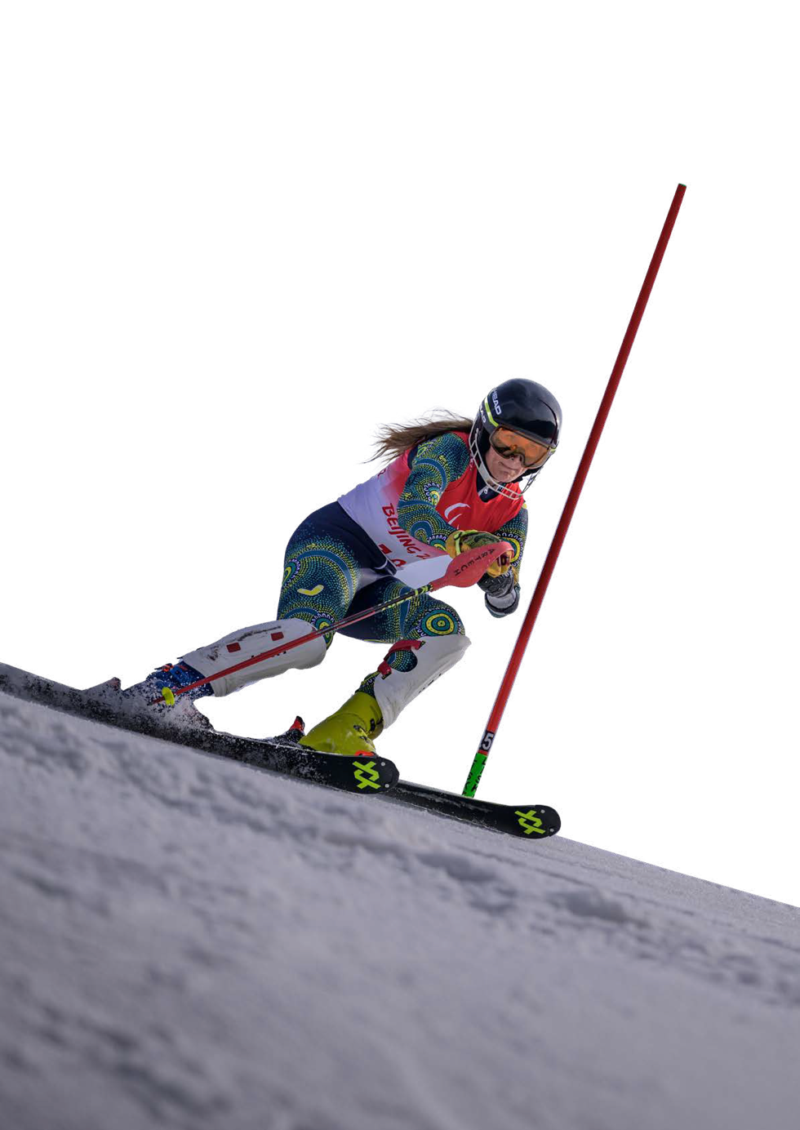

This guide has been produced by Paralympics Australia with input from a diverse range of people working and competing in different sporting codes.

This guide has been developed as part of the Paralympics Australia ParaPower Mentoring Program ILC Grant funded by the Australian Government Department of Social Services.

Acknowledgement of Traditional Owners
Paralympics Australia acknowledges and pays respect to Elders past and present of the lands and waters on which we live, work, and engage in sports together. We are committed to caring for those lands and people across the nation. We acknowledge the diversity, unique histories, cultures, knowledge and current experiences of individuals and communities across Australia. We celebrate their contributions to the nation broadly, and specifically to community and sport.

Continuous improvement
Paralympics Australia is developing its strategy, approach, and content for inclusive and universal design with accessibility experts and people with disabilities through a process of co-design, experimentation, and testing.

We test with diverse users of assistive technologies such as screen readers, screen magnifiers, and alternative navigation.

Through this guide we have endeavoured to use language that is accurate, respectful, inclusive, empowering, and non-stigmatising. We regret any use of language that does not meet this standard or causes offence, whether written by the authors, captured through interview quotes, or included in evidence review citations.

We’re open to any questions or feedback that might help us learn and improve. Please contact Sarah.Stewart@paralympic.org.au with details about your experience and suggested changes. We will listen and respond.

Cover page image
The cover page of this document features the “Celebration” graphic device which has been created to complement the First Nations story as told by First Nations artist, Uncle Paul Calcott. It visually represents community and the world coming together in shared celebration of sporting achievement.

Table of Contents

1.1 Foreword 8
1.2 The facts 10
2 About this guide 11
3 Who this guide is for 13
4 What is inclusive, universal design? 16
4.1 Seven principles of universal design 17
4.2 Eight goals of universal design 18
4.3 Benefits of Universal Design 19
4.4 Inclusivity in sports 20
4.5 Universal design in sports 20
4.6 Definitions 22
4.6.1 Accessibility 22
4.6.2 Inclusivity 22
4.6.3 Universal design 22
5 Practising inclusivity 25
5.1 The inclusive mindset 25
5.2 Inclusive language and communication 26
5.2.1 General tips for communicating with people with a disability 28
5.2.2 Communicating with people with physical disabilities 28
5.2.3 Communicating with people with a vision impairment 28
5.2.4 Communicating with people with a hearing impairment 29
5.2.5 Communicating with people with an intellectual disability 29
5.2.6 Communicating with people with a mental illness 29
5.3 What to say 31
6 Case studies 35
6.1 The Hangar 35
6.2 Inclusive mountain sports at Kaunertal in Austria 37
6.2.1 Barrier-free access and attractions at Kaunergrat Nature Park 38
6.2.2 Barrier-free winter sports 38
6.2.3 Barrier-free accommodation and facilities 39
7 When to consider universal design 42
8 Getting started 46
8.1 Goals 46
8.2 Deciding who should attend 46
8.3 Setting expectations 47
8.4 Meeting preparation 48
8.4.1 Preparing for in-person, physical meetings 48
8.4.2 Preparing for online, in-person and or hybrid meetings 49
8.4.3 Preparing for hybrid meetings 50
8.5 Facilitating the meeting 52
8.5.1 Some considerations for facilitating hybrid meetings. 53
8.6 Tools. 54
9 Inclusive strategy 56
9.1 An inclusive strategic process 56
9.2 Evaluating progress 62
10 Creating an accessible, inclusive document 65
10.1 Key considerations for making a document accessible and inclusive. 66
11 Digital communication and content 71
11.1 The advantages of digital communication 71
11.2 A checklist for assessing if a website or content is accessible. 73
11.2.1 The Web Content Accessibility Guidelines 75
12 Tools – Examples in action 79
12.1 Example meeting agenda. 79
12.1.1 Agenda 80
12.2 Example of an accessible document 83
12.3 Examples of a social media post and video, and approaches for digital content creation 85
12.3.1 Social media posts 85
12.3.2 Video 86
13 Resources 88
13.1 Leading organisations 88
13.2 Resources 89
13.3 Digital accessibility and inclusion (MS, Adobe, Google) 90
13.4 Auslan Services 90
14 Join us 91

01

Introduction

Foreword

Sport has the power to change the world.

Paralympics Australia has an enduring belief: Paralympic sport has the power and a platform to engage, inspire and challenge inequality.

Paralympics Australia aspires to amplify the influence of sport to create positive social change.

We believe sport and society need to evolve to be more inclusive and collaborative; to live and reflect the Australian values of equality, mateship, and a fair go - for everyone.

Remarkable Paralympic moments inspire trust, pride, and respect; they bring us together, catalysing conversations and telling powerful stories from diverse role models.

In 2023, Paralympics Australia began a journey to understand how universal design principles and practice could be applied in Australian sports organisations and venues with the goal of true inclusivity.

In Australia, accessibility is increasingly considered by people who design, develop, and administer sports venues. It is enshrined in industry building codes and organisational policies.

And yet, accessibility is viewed as a minimum requirement, a cost, and therefore often not met.

Accessibility is not inclusivity. It is not universality.

If we are to be inclusive, the experience of playing sport – from club communication and coaching to venue access and competition on the field – needs to be the same for everyone. We need to ‘design for everyone, everywhere, all the time’.

To achieve true inclusivity, we need to inform, educate, and support all Australians playing sport to reflect the diversity of local communities in their clubs and competitions.

After speaking to a range of people working and volunteering in Australian sports, Paralympics Australia has developed this guide.

Our goal is to support people to ask and answer the question, ‘how might we be more inclusive’, with information, checklists, and content for sharing with colleagues and club members.

Paralympics Australia exists to create a more inclusive world.
Paralympic sport challenges mindsets and assumptions about what people with disability can achieve. Sport is a platform to visibly model what systems and structures founded on the principles of universal, inclusive, and accessible design can look like – and the positive social impact they can have for all Australians.

Sport is a catalytic opportunity to unite, inspire and motivate Australians for generations to come: to make inclusion a way of life.

Let’s make that happen.

Catherine Clark
Chief Executive Officer
Paralympics Australia

The facts

We know that of the 4.3 million people with a disability, only one in four participates in sport, while three in four want to participate.

We also know that of the 2.1 million Australians of working age with disability, just 48% are employed, compared with 80% of people without disability. People with disability are also less likely to be employed on a full-time basis than people without disability. When this level of disparity exists in society, it is reflected in sport too.

Australia is a signatory to the UN Convention on the Rights of Persons with Disabilities. There are eight guiding principles that underlie the Convention, they are stated in this list below:

- Respect for inherent dignity, individual autonomy including the freedom to make one’s own choices, and independence of persons;
- Non-discrimination;
- Full and effective participation and inclusion in society;
- Respect for difference and acceptance of persons with disabilities as part of human diversity and humanity;
- Equality of opportunity;
- Accessibility;
- Equality between men and women;
- Respect for the evolving capacities of children with disabilities and respect for the right of children with disabilities to preserve their identities.

Find out more about Australia’s commitments at this link to the Australian Human Rights Commission website.

About this guide

This guide is designed to help people working or volunteering in sports organisations and clubs to understand universal design, and how to get started engaging colleagues and members on the journey to inclusive sport.

When we speak to people who want to make sport inclusive,
there are common challenges standing in their way.

1. Understanding: People are wary of engaging in conversations 2. inclusivity and the changes it may require to how organisations operate because they don’t have a fundamental understanding of how to approach universal design.

2. Confidence: People without much personal experience, worry about engaging with people with disability in case they say or do the wrong thing. That lack of confidence can lead to avoidance.

3. Funding: There is a perception that inclusivity comes with a price tag. Sports clubs and representative organisations run on very little income; therefore, any decision requiring financial investment is met with caution. Council upgrades to facilities happen according to plans made well in advance. It is easy to dismiss suggested changes to a building, or ways of working.

4. Education: Although some codes are providing education to club administrators, coaches, and physical education (PE) teachers in schools, most are unaware of it, and don’t have easy access to training that could help include people with disability.

The good news is that many Australians want to make sport, and society, more inclusive. They are the enablers whose willpower and determination overcome barriers. They are every bit the champions who perform on the sports field.

This guide has been developed to enable the enablers; to support them on the journey to inclusive sport. It acknowledges that the journey to inclusivity takes time. It starts with understanding, learning and a commitment to change.

Listed below, the five goals are to:

- Evolve the mindset of people in sport to one of inclusivity, not just accessibility.
- Embed the fundamental principles of universal design in the minds and decisions of leadership teams in all sports organisations.
- Ensure all strategies, plans, processes, and activities in sport begin by asking the question, ‘how might we be inclusive’?
- Support sports organisations to adopt accessible communication and inclusive language.
- Build a groundswell of support for universal design by growing a network of motivated people and organisations.

Not applying universal design can pose a very real risk to the physical and psychosocial safety of people with disability: as spectators, participants, volunteers, and workers.

Getting it right, opens-up a range of opportunities, from gaining new members to accessing different funding sources.

Most of all, it is the right thing to do.

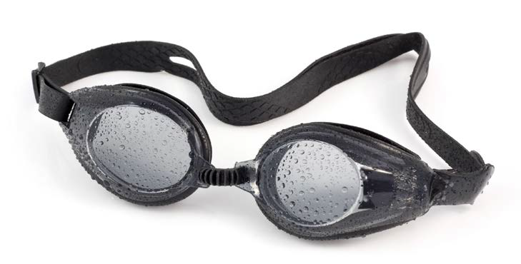
Image description: A pair of goggles sit on a white background

Who this guide is for

If you are a member of a sports organisation or club, then this guide is for you. You may undertake multiple roles in sports organisations and be seeking guidance on a range of ways to be more inclusive. We’ve created a simple process to help you find the information you need.

Firstly, the list below identifies key roles in sports organisations who are well placed to get started on universal design. Then, over the page, is a list of common actions with page numbers in this document at which guidance and tools, relevant to those goals, can be found.

You may be a...

- CEO, state or national sport body
- Funding and development manager
- Diversity and Inclusion manager
- Pathway manager
- Program manager
- Administration manager
- Venue manager
- Procurement manager
- Communications officer
- Member relations manager
- People & Culture (HR) manager
- Office manager
- Club president, board member or team member
- Person with disability
- Family member or friend of a person with disability

Seeking to...

- Understand what universal design is. (see page 16)
- Be inclusive. (see page 23)
- See examples of inclusivity in action. (see page 33)
- Make inclusivity a strategic priority for my organisation. (see page 55)
- Make sure our organisation’s communication is accessible and inclusive. (see Section 10, 11 & 12 of this document)
- Check our organisation’s website and social media content is accessible. (see page 69)
- Find training, tools and resources on inclusive and universal design. (see page 77)

04

What is inclusive, Universal Design?

What is inclusive, universal design?

Throughout this guide, we use the terms ‘accessibility’, ‘inclusivity’ and ‘universal design’.

In sports, a focus on accessibility leads to places and communication materials being designed for use by people with disability. Inclusivity has the goal of creating welcoming communities and places that are experienced similarly for everyone, whether they have a disability or not.

Inclusivity leads to a common experience for all, whereas accessibility provisions continue to ‘other’ people with disability.

Every inclusive process is human-centred. A human-centred approach begins with empathy for the people will use the product of the design process. Wherever possible, it should include people with ‘lived experience’. For example, if you are creating a new website and you want to be truly inclusive, ask someone who is vision impaired to go on the journey with you.

Universal Design is a design philosophy and practice. Its originator, Ron Mace, of North Carolina State University, envisioned universal design as to promote design of products and environments that appeal to all people, while meeting the requirements of new government legislation related to people with disabilities. His idea was that “design of products and environments should be usable by all people to the greatest extent possible - without the need for adaptation or specialised design”.

Since then, universal design has been embraced by governments, institutes, engineers, architects, software developers, and industrial designers across the world.

Seven principles of universal design

The seven principles of universal design can be applied in the way we think about and act within workplaces and communities. They are:

- Equitable use. The design does not disadvantage or stigmatise any group of users.
- Flexibility in use. The design accommodates a wide range of individual preferences and abilities.
- Simple and intuitive use. Use of the design is easy to understand, regardless of the user’s experience, knowledge, language skills, or current concentration level.
- Perceptible information. The design communicates necessary information effectively to the user, regardless of ambient conditions or the user’s sensory abilities.
- Tolerance for error. The design minimises hazards and the adverse consequences of accidental or unintended actions.
- Low physical effort. The design can be used efficiently and comfortably and with a minimum of fatigue.
- Size and space for approach and use. Appropriate size and space is provided for approach, reach, manipulation, and use, regardless of the user’s body size, posture, or mobility.

Source: Centre for Inclusive Design and Environmental Access,
University of Buffalo.

Eight goals of universal design

The eight goals of universal design guide any design process.

They encompass the functional, social, and emotional dimensions of individuals and communities, and the spaces they inhabit.

They are defined within three linked areas: 1) human performance (body fit, comfort, awareness and understanding) linked through 2) wellness to 3) social participation (social integration, personalisation and cultural appropriateness).

The eight goals are as follows:

- Body fit. Accommodating a wide range of body sizes and abilities.
- Comfort. Keeping demands within desirable limits of body function and perception.
- Awareness. Ensuring that critical information for use is easily perceived.
- Understanding. Making methods of operation and use intuitive, clear, and unambiguous.
- Wellness. Contributing to health promotion, avoidance of disease, and protection from hazards.
- Social integration. Treating all groups with dignity and respect.
- Personalisation. Incorporating opportunities for choice and the expression of individual preferences.
- Cultural appropriateness. Respecting and reinforcing cultural values, and the social and environmental contexts of any design project.

Benefits of Universal Design

There are obvious benefits to universal design:

- Efficiency, and cost saving. Rather than make multiple versions of things for people of different abilities, make it once, with the reduction in attributable effort, risk, and financial costs.
- A bigger community. If something is designed for everyone, everyone can participate. That means more members at the sports club, which might also mean more funding and a more sustainable code.
- Better design. When you invite diverse people into a design process, you get diverse perspectives. That means learning new ways of thinking and doing things, which leads to new ideas and outcomes.
- Diversity. Australians are diverse, and universal design considers that diversity – not just people with disability, but people from different ages, cultural backgrounds, genders, and many other identities. For example, a wheelchair ramp installed at sporting stadium doesn’t only benefit people in wheelchairs, but also sportspeople with gear, spectators with luggage, delivery people with trolleys, and parents with prams.
- Living our values. Australians are proud of their egalitarian values. Those values bring people together and sport is a prominent feature of Australian life. Excluding people is not who we are. To design for everyone is to be more of ourselves.
- It’s the right thing to do. As a signatory to the United Nations Convention on the Rights of Persons with Disabilities, Australia has committed to ‘full and effective participation and inclusion in society’ of people with disability. That’s because our governments, acting on our behalf, know it’s the right thing to do.

Inclusivity in sports

In a sports context, inclusivity looks like:

- Leaders of a sporting club making a public statement that the club is inclusive and wants to work with the community to apply universal design principles, progressively improving over time.
- Using accessibility guides and software to produce communication materials everyone can read.
- Diversity of people in an organisation at all levels (e.g. People with disability in all areas – as athletes, parents and guardians, coaches, managers, staff, executives, volunteers, board members, etc.)
- Providing free inclusivity training and resources to club members.
- Using inclusive language. And being prepared to get it wrong but learn along the way.

Find out more by clicking this link to the IPCs Accessibility Guide

Universal design in sports
In a sports context, universal design looks like:

- Conducting research to ask people with disability and their families what they would like to see from the sport, the club and/or venue.
- Designing an annual sports calendar that includes activities everyone can be involved in
- Develop a sports program for older people and people with disability.
- Helping coaches access training and education to work with people with disability and consider para sports opportunities.
- Making inclusivity a strategic priority, which informs all activity.
- ‘Walking in the shoes’ of people with disability to identify and address all barriers to accessing a carpark, venue, or sports field. And, using that information to attract funding from government partners.

Image description
Tyan Taylor, Australian B3 goalball winger, blocks the ball as she slides across the court.

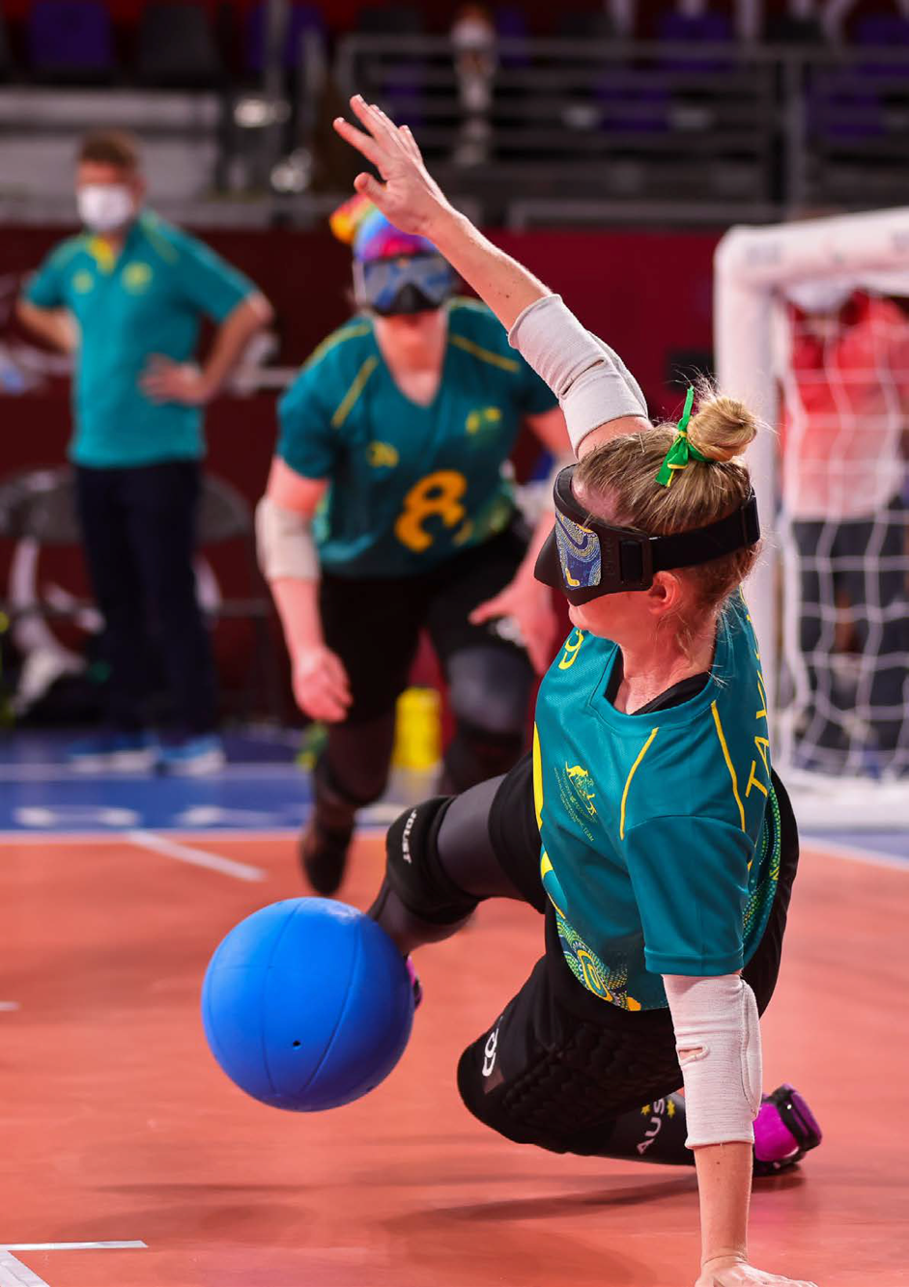

Definitions

Accessibility

Accessibility is the practice of making information, activities, and physical spaces accessible, navigable, and usable for people with disability. Examples of accessibility are producing documents that can be read by someone who is vision impaired, or installing ramps and wide enough doorways so that people in wheelchairs can enter a building.

Inclusivity

Inclusivity is a philosophy, mindset, and practice through which places, activities and communication are experienced equally by every person.

Universal design

Universal Design is a design philosophy that ensures that products, buildings, environments, programs, services, and experiences are innately accessible to as many people as possible, regardless of their age, level of ability, cultural background, or any other differentiating factors.

These quotes below are how some people define Universal Design:

“Good design is felt, not noticed.”
“Design for everyone, everywhere, all the time”
“Design that makes room for everyone.”
“Good design is when you don’t notice it.”
“Universal Design is the silent proclamation of an inclusive world.”

05

Practising Inclusivity

Image description
Ella Sabljak, Australian 2.5-point wheelchair rugby player, pushes away from the opposition with the ball in her lap.

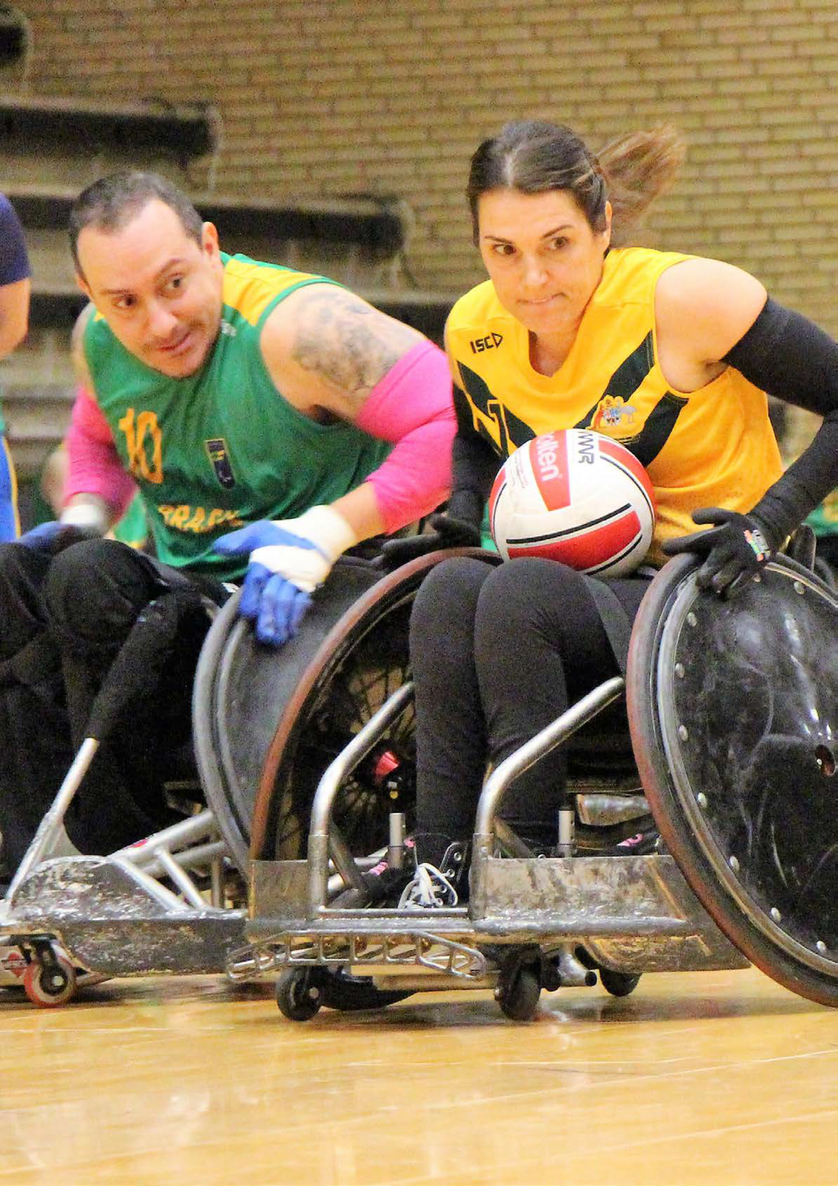

Practising inclusivity

Inclusivity is a philosophy to live by. Afterall, to be included and to belong, is a basic human need.

Historically, Australia and many other countries have been home to
societies that ‘other’ people with disability.

In sports settings, people with disability can be placed in separate venues and different rooms or classrooms. They are treated and spoken to differently.

That’s pretty crazy when you think about it. People living with disability don’t want different experiences from other people. They want, and are entitled to, the same experiences. Afterall, if you love footy, you love footy!

Fortunately, attitudes are changing, but we still have a long way to go. To get there, we need every Australia to adopt an inclusive mindset, and live an inclusive life.

The inclusive mindset

People with an inclusive mindset are curious, kind, aware, and openminded. They have empathy, a respect for others and a lack of ego.

An inclusive mindset is about making sure diverse perspectives are heard, understood, and applied; and, decisions are reached collaboratively.

People with an inclusive mindset are comfortable asking questions and listening to answers and working within a diverse team. They have a self-awareness that their views, and the way they see the world, may not necessarily be shared by everyone else. And that’s a positive thing; it’s a chance to grow.

People with an inclusive mindset use inclusive language. Inclusive language is words and phrases that avoid biases, slang, and expressions that discriminate against groups of people based on race, gender, socioeconomic status, and ability.

Like other behaviours, an inclusive mindset is developed over time. The important thing is to get started and practice it. Be comfortable ‘learning while doing’ because, if you use inclusive language, people will always forgive any mistakes and help you on the way.

Ultimately, being inclusive, means starting every meeting and every task with the question: ‘How might we be inclusive’.

Press this link to watch a video on inclusivity from Vinnies NSW.

Inclusive language and communication

Just like their peers without disability, people with disability who play and watch sport want to feel welcome. That starts with the words we use and how we express their meaning.

Inclusive language is culturally appropriate and respectful of the diversity of Australia’s peoples.

Disability does not define people or the life they want to lead. So, when talking to people with disability, focus on the person, not the disability.

Mention disability only when it’s relevant to the content of a discussion or communication.

Be open to feedback on the language you’ve used and be responsive. Ask and listen to the person/group you are conversing with and be willing to change to their preferences.

There are different types of disability, categorised as:

- Physical disability
- Vision impairment
- Hearing impairment
- Intellectual disability
- Mental illness

Any one person may have one or more impairments and many disabilities are not visible or obvious (these are commonly known as ‘hidden disabilities’).

Fortunately, there are some common-sense guidelines to use when communicating with people with disabilities.

Use person-first language (‘people with disability’) rather than identity-first language (‘disabled person’) but ask and listen to the person/group you are conversing with and be willing to change to their preferences.

Also be aware that these conventions continue to change and evolve. If in doubt, ask.

Avoid using the word ‘disabled’ as an adjective that defines the person unless that is their preference. Use the word ‘disability’ as an uncountable noun. Describe the person and then the characteristic.

Before you produce any documentation or digital content, understand user needs and make it accessible. Use respectful and inclusive language that talks to the person – not their difference. Respectful language acknowledges peoples’ references to identify with a particular community or characteristic.

Terms should not identify people without an understanding of their personal preference. For example, many people who are deaf or hard of hearing may identify as ‘Deaf’ – a cultural group with a different first language. Others might not.

General tips for communicating with people with a disability

- Speak to a person with a disability as you would speak to anyone else.
- Speak in an age-appropriate tone and treat adults as adults.
- If a person with a disability is accompanied by another person, such as a carer, you should still speak directly to the person with disability.
- Put the person first, not their disability. For example, use the term ‘a person with disability’ rather than ‘a disabled person’.
- Avoid negative phrases such as ‘suffers from’ and ‘crippled’.
- Use the phrase ‘people who use a wheelchair’ rather than ‘wheelchair bound’.

Communicating with people with physical disabilities

- Remember that someone’s personal space can include their wheelchair and crutches. Don’t touch or push a person’s wheelchair, and don’t move their crutches or walking stick without their permission.
- When speaking with a person who uses a wheelchair, where practical, try to find something to sit on to be at eye level with them.

Communicating with people with a vision impairment

- When you meet people who have a vision impairment, always address them by name and introduce yourself.
- Speak clearly and in a normal voice – there is no need to raise your voice.
- Remember that people with vision impairment can’t rely on the same visual cues as people without a vision impairment. Make sure you verbalise any thoughts or feelings.
- If a person is accompanied by a guide dog, don’t pat it, feed it, or distract it while it’s in a harness. A dog in a harness is working to support its owner.
- When you enter or leave a room, say something to make sure that the person who has a vision impairment won’t be embarrassed by speaking to an empty space.
- If taking group photos, ask the photographer to let the participants know which way to face for the photo so they are looking in the right direction. Do not move the guide dog or the person's cane away, they are part of the person's personal space.

Communicating with people with a hearing impairment

- Gain the person’s attention before speaking. Try a gentle tap on the shoulder, a wave, or some other visual signal to get the person’s attention.
- Face the person directly and maintain eye contact.
- Make sure your mouth is visible – don’t cover it with your hand or any other object as you talk.
- Look directly at the person while speaking and don’t speak too fast or too slow.
- Don’t exaggerate your mouth movements – this will only make it more difficult to lip-read.
- Use short sentences.
- Keep your volume at a natural level – don’t shout.
- Not all people can lip read or read Auslan. Prepare notes in advance of meetings and distribute them.

Communicating with people with an intellectual disability

- Make sure you have the person’s attention before you start talking.
- Try using their name or making eye contact.
- Keep your questions simple and your answers easy to understand.
- Remember that your body language is important because people with an intellectual disability often rely on visual cues.
- Be prepared to use visual information or to get visual information from people with an intellectual disability.
- Be specific and direct. Avoid talking using abstracts, acronyms, metaphors, or puns.

Communicating with people with a mental illness

Mental illness is a health issue that can significantly affect how a person feels, thinks, behaves, and interacts with other people. Mental illness is a general term that refers to a group of illnesses including, but not limited to:

- Mood disorders (such as depression and bipolar disorder)
- Anxiety disorders
- Psychotic disorders (such as schizophrenia and some forms of bipolar disorder).

One of the common mistakes people make when talking to someone with a mental illness is talking too much. When we are talking, we are not listening.

The best thing to do is to say less and listen more.

- Be respectful to the person. People who feel respected and heard, are more likely to return respect and consider what you have to say.
- Some people with paranoia may be frightened, so be aware that they may need more body space than you.
- Instead of directing the conversation at them with ‘you’ statements, use ‘I’ statements instead.
- Ease into the conversation gradually. It may be that the person is not in a place to talk, and that is OK.
- Be sure to speak in a relaxed and calm manner.
- Talk to the person in a space that is comfortable, where you won’t likely be interrupted and where there are minimal distractions.
- Do not lie, as it will usually break any rapport you might want to establish.
- Be aware of a person becoming upset or confused by your conversation with them.
- Listen to the person and try to understand what they are communicating.
- Communicate in a straightforward manner and stick to one topic at a time.
- Be a good listener, be responsive and make eye contact with a caring approach.
- Give them the opportunity to talk and open-up; but don’t press.
- Reduce any defensiveness by sharing your feelings and looking for common ground.
- If needed, set limits with the person as you would others. For example, “I only have five minutes to talk to you” or “If you scream, I will not be able to talk to you.”

What to say

Say this:
- person with disability
- person with hearing impairment
- person with vision impairment
- person living with disability
- person with mental illness, person with psychosocial disability, person with a psychiatric condition
- person with intellectual disability, person with developmental disability
- person with learning disability
- person with cognitive disability
- person who uses a wheelchair or mobility device
- person with reduced mobility
- person with physical disability
- accessible parking

Don’t say this:
- person with a disability
- handicapped person
- handicapped parking
- crippled
- invalid
- incapacitated
- mad
- mute
- deaf and dumb
- deaf person
- blind person
- person without sight
- a person is inspirational because of their disability.

When you make comparisons, write:
- ‘person without disability’ – rather than ‘able-bodied’
- ‘sighted person’ for someone who is not blind
- ‘hearing person’ for someone who is not deaf
- ‘neurotypical’ for someone who is not autistic and ‘neurodiverse’ for someone who is not neurotypical.

This information was sourced (and edited) from the Australian Government style manual. Visit the website using this link.

Image description: Three tennis balls sit on a white background

06

Case Studies

Image description
Susan Seipel, Australian
Para-canoeist smiles as she gives the thumbs up while sitting in her canoe, on the water.

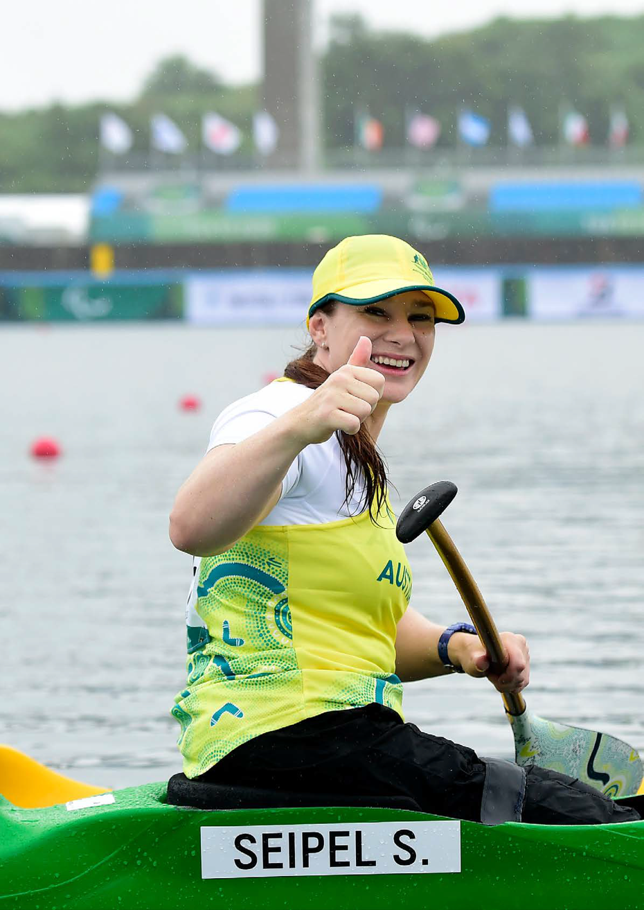

Case studies

The Hangar

The Hangar is the shared Essendon Football Club and Australian Paralympic High Performance Training Centre located on the grounds of the former Essendon Airport. The facility officially opened in November 2013 and has undergone successive developments since.

The facilities include large locker rooms for players, an indoor aquatic centre, a running track, a gymnasium, medical and administration offices, and two football ovals - one the size of the Melbourne Cricket Ground and the other the size of Melbourne’s Docklands Stadium. The venue’s most obvious facility is the 60 metre long, 40 metre wide, indoor training hall which looks just like an airplane hangar.

The Hangar is home to high performance Para Sports training programs for wheelchair basketball, wheelchair rugby, and table tennis.

When designing the Hangar, the goal was a universal experience. To do that, the premise was to move beyond thinking ‘how might we accommodate disability’ to ‘how might all accessibility needs in the building be met’? That started with an audit of all the touchpoints a visitor/user is likely to have as they move through a sports facility, and determining what a universal experience might require.

All sports people have common needs, for example:

- Informed, experienced and capable front desk staff who can answer your questions and guide you to the right facilities quickly.
- Toilets, and health and safety facilities, immediately adjacent to the training ground.
- Lighting and signage that makes it easy to find the room or ground you are meeting or training in.
- Accommodation with enough space for your gear, and morning routine.

Image description:
A team gets ready for the National Institute Network (NIN) Challenge for wheelchair basketball at The Hangar in Melbourne. Image courtesy Basketball Australia

The Hangar has purpose-built dormitory accommodation to house Australia’s Para-athletes and is the home of Paralympics Australia’s Victorian office. An inspiration to Para-athletes, The Hangar recognises and reflects the rising profile and potential of Para Sport in Australia.

The Hangar answers common needs establishing from the outset that sport welcomes all people.

It is also home to the Glory and Fame Sports Museum, which invites members of the public to see a range of displays including extensive written, photographic, and video material detailing the Australian Paralympic movement’s athletic, technological, and cultural history.

Watching the Essendon or the Para sports athletes train, or visiting the museum, brings the broader community together to help increase understanding among spectators and players about different codes, and abilities. It breaks down attitudinal barriers through shared experience.

For Para sports people, entering The Hangar reaffirms that you are an elite athlete, which is the critical motivation to be competitive nationally and internationally.

And you are welcome to visit!

Inclusive mountain sports at Kaunertal in Austria

Kaunertal is a municipality and alpine valley in the Austrian state of Tyrol, famous for its skiing and nature walks. The Kaunertal ski resort made a commitment to what they call, “Barrierefreier Wintersport”, which translates as ‘barrier-free winter sport’.

With a philosophy of inclusivity, the resort has been through a process of universal design, making it the only truly accessible ski resort in the world.

Visiting the Kaunertal website you immediately feel the welcoming, inclusive spirit in the language and images of people, of diverse age and ability, enjoying the ski fields and natural parkland. It is a resort for everyone.

The barrier-free philosophy is a particular focus in the following three areas:

1. Excursions and hikes into natural parklands
2. Winter sports
3. Accommodation and facilities

Barrier-free access and attractions at Kaunergrat Nature Park

The barrier-free attractions at Kaunergrat Nature Park include:

- Kaunergrat Nature Park Museum
- Fully accessible Gacher Blick nature and culture panorama view
- The Piller Moor natural monument with a 700m accessible
- wooden walkway
- An accessible playground for people with reduced mobility

Image description:
A competitor in the annual Handbike Battle up the valley at Kaunertal.

Barrier-free winter sports

Winter sports include:

- Obstacle free Alpine skilling. The Kaunertal Glacier is a designated monoski area.
- Four, certified barrier-free, cross-country ski runs through the Kaunertal Valley.
- The annual Handbike Battle which starts at the toll station at an altitude of 1,287 metres and heads up 20 kilometres to the Ochsenalm
- Valley station at an altitude of 2,150 metres. The Battle draws spectators eager to watch handbike athletes compete each year.

Barrier-free accommodation and facilities

Accessible, inclusive design features at the resort include:

- Fully accessible ski and accommodation lifts, with all lifts reachable
- at ground level.
- Parking available directly on the slopes for mono-skiers and those
- with disabilities.
- Trained staff with experience facilitating barrier-free sports and tourism.
- Accessible accommodation apartments and dining, with free-flow areas and wheelchair-accessible toilets.

Since 2013, Kaunertal has received several accessibility awards, including the EDEN Award (European Destinations of Excellence), Tirol Touristica Prize, and TOP 5 Alpendestination at theALPS Awards.

For more information, visit the Kaunertal website:
https://www.kaunertal.com/en/Your-kaunertal/Accessible

07

When to consider universal design

Image description
Matthew Levy OAM, Australian Paralympic swimmer, takes a breath as he powers through the pool.
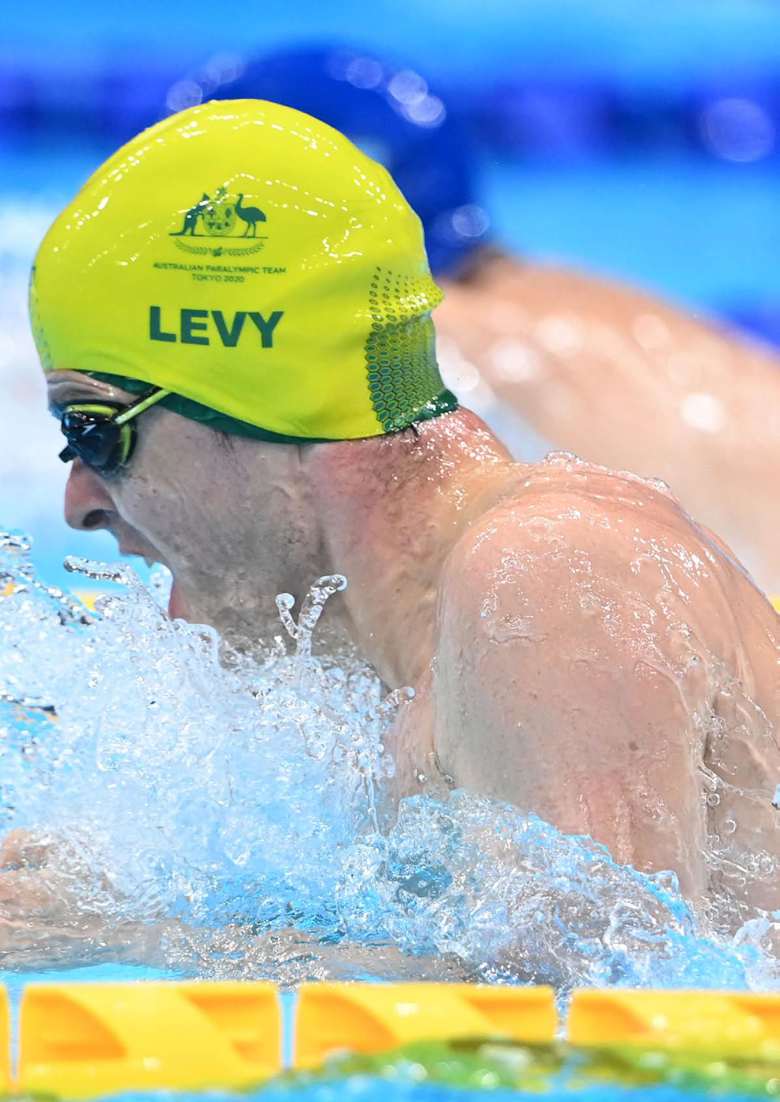

When to consider universal design

If we are approaching every day with an inclusive mindset, then we will see many opportunities for applying the principles and goals of universal design.
In our research what we have heard is:

- Everyone should feel welcome. We all want to feel welcome. When athletes feel welcome and included, they are motivated and achieve higher performance on the field.

- The practical considerations are often overlooked. Sports people with disability often have to arrive at venues early to scout for risks, navigate transport, prepare venue staff, and check how accessible the field/courts are. It is a significant effort. Understanding that journey from their perspective quickly highlights all the things that could be changed to make the experience inclusive.

- Mitigating risk benefits everyone. There are very real risks for people with disability if universal design is not applied, particularly in building design and specifically for people who are vision impaired. Those risks are owned by the venue, club or organisation and should be addressed.

- The importance of the strategy and funding cycle. Almost all sports funding is via government grants, member fees, or community fundraising. Funding activity aligns with strategy and budgeting activity, and this is when accessibility and inclusivity need to be defined to meet grant criteria. However, often, accessibility and inclusivity are not a guiding principle or focus of a strategic or design activity; they are referenced to ensure compliance. This means, after the process is complete, there is a return to business as usual. That’s a missed opportunity to grow the member base, grow the sport, and attract more funding.

4.3 million Australians live with a disability. That’s a huge audience and potential member base for sporting codes and clubs.

So, let’s consider the weekly and yearly patterns of people in sport and place some of the key moments.

- Sending an email
- Creating a presentation or document
- Hosting a meeting
- Planning an event
- Developing a match schedule
- Developing the coaching program
- Writing a funding proposal
- Developing a strategy and/or plan
- Putting a notice on the noticeboard

08

Getting started

Image description
Jonathan Goerlach, Australian Paratriathlete and guide, in mid-flight as they run down the blue athletics track.

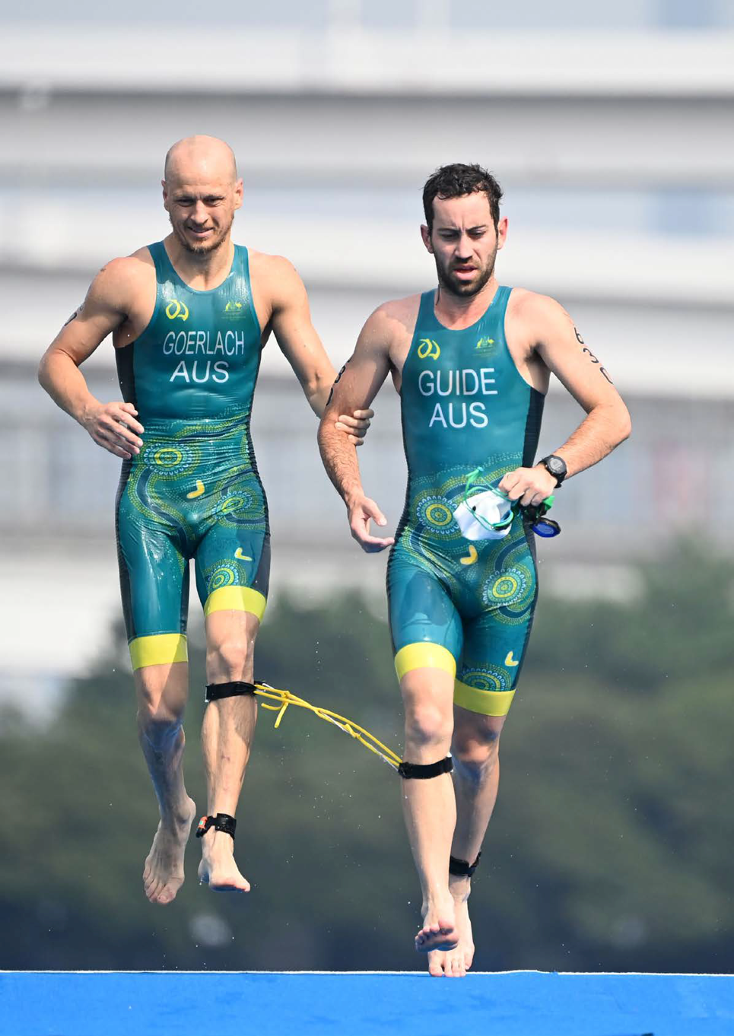

Getting started

The first step on the journey to inclusivity is gathering colleagues and peers to discuss what universal design is, and how it can be applied in your organisation and community. That is, holding a meeting about inclusive/universal design.

Preparing for, facilitating, and responding to that meeting are all opportunities to lead by example, showing people how easy it is to get started, and rewarding to get moving.

To ensure an inclusive and accessible online meeting, consider the diverse needs of all participants.

Adopt and practice the inclusive mindset. This is not a meeting that needs to cater for people with disability or any other group - it is a meeting in which anyone should feel welcome and participate equally.

Goals

The goals of your meeting are:

- Demonstrate inclusive language and behaviours.
- Introduce the meaning of inclusivity and the principles of universal design.
- Define the benefits of inclusivity and universal design.
- Discuss and identify focus areas for the organisation to begin or build its journey to inclusivity.
- Create a safe and welcoming space for people to ask questions.
- Provide case studies and references for further reading.
- Gain support for the next step on your journey.

Deciding who should attend

Consider the goals of the meeting and who should be present.

- People in leadership roles - such as a board member or CEO - have a responsibility to understand universal design, and practice diversity and inclusion. They also have more capacity to influence people, and secure access to financial support.
- People with disability, who are comfortable talking to people less familiar with Para Sports or living with disability, can give a lived experience perspective and respond to questions.
- Some people have roles that are important to achieving inclusivity, such as people in communication, finance, secretarial, operations, procurement, human resources (people and culture), building maintenance, refereeing/umpiring, and coaching roles.

Setting expectations

You are on an exciting new journey!
The key to generating support for universal design is to build momentum at a comfortable pace for participants. Explore a vision for what universal design can mean for your organisation. Help define the journey to get there, acknowledging it will take time, and every step is an opportunity to learn, be creative, and engage the community.

Encourage participation.
This is not a university lecture. You are creating a safe and welcoming space for people to ask questions and communicate their concerns or perceived barriers to progress. By listening and encouraging discussion, you will leave the meeting with clear focus areas: the quick wins, and the longer-term challenges. People should leave the meeting feeling a sense of potential, and energised by what they now know and can achieve.

Use a range of content and media/tools.
People have different learning styles: some like to read and study; others prefer to learn through group interaction. There are many freely available videos, guides, and educational experiences hosted online by community and advocacy organisations, governments, and government agencies.

Avoid overwhelming participants.
For most people, inclusivity and universal design are new concepts. They can feel challenging and difficult to understand, and therefore adopt in practice. Keep it simple with plenty of space for discussion.

Meeting preparation

Preparing for in-person, physical meetings

If the meeting is held in-person, with attendees in a physical space, that space may need to be accessible or, if not, have support provided for people with disability (or older people) to attend.

When you host an in-person meeting or event, look for a venue that:

- Is accessible to wheelchair and mobility aid users, both in relation to entering the venue as well as moving around inside the venue (see section 10 below for further information on venue layout).
- Has accessible toilets.
- Has a public address (or PA) system (microphone and speakers) for meetings or events in a space with poor acoustics or when hosting 16 or more people.
- Is close to accessible public transport and multiple accessible parking spaces, and a carpark next to the venue (see section 4 below for further information on transport);
- Has an accessible reception desk or registration area (for example, consider the height of desks, presence of stairs and placement of signage);
- Has nearby access to a park or greenery where assistance animals can take breaks.

Also, ask participants if the following resources can help:

- Hearing loops
- Auslan (sign language) interpretation

See the resources section of this guide for more information.

Preparing for online, in-person and or hybrid meetings

Provide information for attendees to read before the meeting:

- Invitations should include an opportunity for participants to inform event organisers of any accessibility requirements. For example: “If you have any dietary, access, or support requirements, please let us know and we can arrange any reasonable adjustments. Please note: the venue is accessible for people using wheelchairs and other mobility aids.”
- Clearly include the name of a contact person and their phone and email details so that invitees can get in touch with any queries or requests prior to and on the day of the event.
- All preparatory materials should meet readable text guidelines, especially in relation to minimum font size, font type, layout, and colour contrast. Digital invitations should be readable by screen readers, including alternative text (‘alt-text’) for images. Screen readers cannot read text that is designed into an image file.
- If possible, offer to have an Auslan interpreter present on request, or to help your attendees comfortable with being inclusive.

- See tools and resource pages to assist with material preparation.

Image description: A basketball sits on a white background

Preparing for hybrid meetings

A hybrid meeting is a mix of in-person and online attendees. Hosting hybrid meetings can present unique challenges bringing groups together from both remote and in-person locations with the goal of all individuals participating equally, without facing barriers to accessing the meeting’s content.

Virtual meeting software (such as Zoom or MS Teams) offers greater flexibility of use, and more accessibility features, than alternatives (such as a telephone-based hybrid meeting).

Whenever possible, the physical (in-person) portion of a hybrid meeting should be held in a room with a large screen and with integrated speaker and microphone systems, as this permits a better visual and audio experience for all participants.

Before the meeting

- Determine the purpose, format, and overarching goals of the meeting. For example, will participants view/hear a keynote speaker, or is the goal meaningful communication within your internal team?
- Determine how many participants will be present, who will be speaking, and where the physical meeting will take place.
- Determine what print or video materials will be used, and what platform may be used to register for a meeting or event (if applicable), and ensure they meet digital accessibility standards. More information on purchasing accessible technology can be found on the Digital Accessibility Services website.
- If the meeting will be in a room that you have never used before, visit the room to get a sense of the size, furniture set-up, and audio/visual technology that exists to plan the best setup.
- Enlist local IT support to go over setup for room audio and video to develop a plan so all participants can be seen and heard.

Setting-up the physical space

- Ensure there are no physical barriers such as stairs or heavy doors, to accessing the physical space for the meeting.
- Audio (microphones): ensure the room is equipped with enough high-quality microphones so remote participants can hear clearly. If multiple microphones are not a viable option, consider supplementing your audio input by having in-person attendees pass around a hand-held microphone before speaking.
- Audio (speakers): when using a central audio source in the room, ensure that on-site participants turn off the volume on individual devices if applicable.
- Video: plan to capture all aspects of the meetings for those who are joining remotely – including the faces of all in-person attendees, shared presentations and documents, and materials. For example, use one camera (i.e. on a laptop, mounted to a tripod, etc.) to face in-room attendees. This permits participants who rely on lip reading for communication to access that information. If applicable, use a second camera to be moved to display close-up views of presenters, flip charts, wall charts, etc.
- Captions: Ensure that captions and subtitles can be viewed simultaneously by online participants and in-person participants. For example, live captions could be on a display on a central screen(s) in the room while also being available on the remote meeting platform.
- Speaker space: if speakers will be in an elevated location, ensure that a ramp or lift is available to facilitate speakers or participants accessing the elevated location. If a podium is to be used, ensure it is adjustable or that modifications can be made so that participants of any height may use the podium. Ensure that video equipment can be repositioned to accommodate a range of speaker heights.

Setting up the remote space

- Plan to mute participants that are not actively speaking to minimize feedback and noise. Decide if participants should be able to unmute themselves.
- Enable the live automatic captioning feature, if available in your web conferencing platform (note that if the meeting is held through Zoom, this must be done in advance of sharing a meeting link).
- Ensure that online waiting rooms are disabled so online participants that lose connection can easily rejoin without disturbing the hybrid meeting.
- Disable the doorbell sound for participants entering the room so it does not disturb a meeting in progress.
- In advance of the meeting, provide attendees with accessible digital materials and share within the web conferencing platform or email to attendees.
- Start the meeting a few minutes early to allow participants time to log in and resolve any technical issues.

Facilitating the meeting

Use live captions.
Using built-in captions/live transcription is important to ensure all participants can understand and follow the discussion. Many popular video conferencing platforms, such as Microsoft Teams, Zoom, and Skype, offer this feature. Captions can help people with hearing impairments and those who struggle with accents or speaking styles that differ from their own. It also improves the meeting's overall accessibility and inclusivity.

Use plain and inclusive language.
Use plain and inclusive language to ensure all participants can understand the information. Also, make sure text is easy to read with good colour contrast and a readable font size. Describe your appearance when introducing yourself. (E.g. “I’m Mel and I’m wearing a blue shirt with yellow flowers; I have short brown wavy hair.”)

Mute all participants or ask the participants to mute their microphones.
Muting all participants or asking them to mute their microphone reduces distracting background noise for attendees and ensures everyone can hear the information being shared.

Repeat or paraphrase questions.
This ensures that all participants can understand the questions being asked and can provide an answer if necessary.

Provide breaks between agenda items.
Providing a break between agenda items is not only beneficial by allowing all participants to take a moment to stretch, but it also gives Auslan interpreters, captioners, note-takers, and support workers a break.

Ensure that participants who use co-located Auslan interpreters are visible on the screen.
If a participant is using a co-located Auslan interpreter, it’s important to ensure that the focus is on the participant and not the interpreter. This way, all attendees can clearly see the person speaking and understand the conveyed information without any hindrance. If more than one participant is using a co-located Auslan interpreter, each interpreter may need to be visible.

Some considerations for facilitating hybrid meetings.

During the meeting:

- If individual, in-person participants are using laptops to ensure that all participants are on video, ask each participant to turn the volume off on their laptops, and mute themselves, so that audio can be channelled through room microphones and speakers.
- Designate a moderator: assign someone to guide and facilitate the conversation, monitor the chat online, and call on people who have their hands raised. The moderator can also provide reminders when needed to help keep communication clear, such as reminding people to use the online chat and use microphones. If audio is being channelled through microphones in the room, zoom will not highlight the speaker producing the audio. Therefore, the moderator should manually spotlight speakers on the video so that remote participants can see the speaker, including to access lipreading if they use that for communication.
- Establish expectations and meeting etiquette at the start of the meeting, such as:
  - Ask participants to silence phones/devices.
  - Ask participants to keep their devices on mute unless speaking.
  - Ask participants to raise their hand and identify themselves before they speak (which also encourages turn-taking). This allows everyone to follow along, regardless of their location.
- Provide an audio description of all visual meeting content (such as content on slides) so that those participating by telephone or participants who are blind or have low vision can access the content (slides shared through zoom’s screen sharing feature are not compatible with screen reader technology).
- Repeat back or paraphrase what participants say.

Tools.
Meeting agenda
See the suggested meeting agenda in the Tools section of this guide. It can guide the meeting, helping facilitators to stick to time as well as motivate participants.

Video content
See the Resources section of this guide for a list of useful videos.

Case studies
Use the case studies in this guide or, if you can, find some local examples.

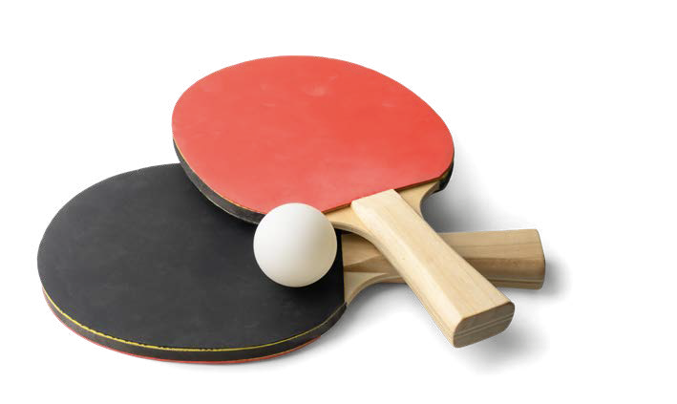
Image description: Two table tennis bats sit on a white background

09

Inclusive strategy

Inclusive strategy

The strategy and funding cycles are usually aligned for sports organisations. Funding is commonly sourced through government grants, philanthropic organisations (charities) and business sponsorship. Increasingly these organisations are seeking commitment to diversity and inclusion and are more likely to support organisations that provide evidence of their commitment to inclusivity.

The strategy and plans of an organisation guide behaviours and outcomes. Leaders communicate the strategy, establishing the importance of strategic priorities and actions the success of the organisation. The outcomes of actions are measured, thereby focusing the team on achieving results within set timeframes.

So, how might an organisation embed inclusivity in strategy and planning?

An inclusive strategic process

Adopt an Inclusive Mindset.
- Prepare everyone contributing to the strategic process with guidance on adopting an inclusive mindset.
- Begin each meeting and stage by asking, ‘how might we be inclusive’?

Set expectations and make commitments.
- Sports organisations have limited resources. Achieving inclusivity will take time. Establish a high-level road map for your multi-year journey.
- A commitment to universal design means setting goals, allocating investment and reporting on outcomes. It’s how employees and stakeholders know an organisation is ‘walking the talk’. Make the goals realistic but also meaningful: people want to see progress in areas that matter most.

Diversity in representation.
- Establish diverse representation from employees and members or stakeholders in the research, strategy, and planning process.
- Recognise and appreciate different backgrounds, perspectives, and experiences.
- Use a co-design approach to create a safe and welcoming space for diverse participation. Adopt the principles of: power sharing; prioritising relationships; facilitated participation; building capability for equitable participation and implementation.

Equity and fairness.
- Review your organisation’s policies and practices to understand where work might need to be done to achieve best practice or compliance.
- Consider the common cognitive subconscious biases that influence people’s perceptions about change and ability, and discuss how to address them.
- Establish where systemic bias exists. For example, a grant application process might not enable a universal design approach through its structure and criteria. Approach the funder and encourage change.
- Consider how to provide equal opportunities for all individuals to engage in sports and related community activities.

Check your cognitive biases with this link to a codex.

Inclusive language.
- When facilitating the strategy and funding process, and in the resulting documentation, use language that is respectful and inclusive of all individuals, avoiding terms that may be exclusionary.
- Promote and foster environments where everyone feels comfortable expressing themselves.

Training and education.
- Refer employees or members to free diversity and inclusion training so they can build their knowledge and confidence.
- Refer to the organisation’s policies in sessions that ask participants, ‘what does this policy look like when we adopt it in our work and activities?’

Press this link to take some free eLearning courses.

Leadership.
- Leaders in the organisation – the board, executive team and people
- managers – can demonstrate commitment to inclusion through their communication and behaviour.
- The role descriptions and KPIs of leaders can include expectations regarding inclusion.
- Leaders should include inclusion as a factor when making and communication decisions.

Flexible policies and work.
- Emerging from the strategy process, implement policies that allow for flexibility in work hours, remote work, or other arrangements that accommodate diverse needs.
- Consider designing jobs and teams for people of all abilities rather than assessing applicants against standard job arrangements and requirements.
- Recognise and support work-life balance.
- Listen to and act on reasonable adjustments requests. It is not accessible and inclusive if it is always on the employers’ terms.

Celebrate achievements.
- Celebrate achievements of the inclusive strategy process and funding applications with employees and stakeholders.
- Reinforce the value of diverse perspectives and participation.

Anti-discrimination.
- Establish a reference for people learning about inclusivity.
- While encouraging positive participation, make it clear what not to do, and what is not acceptable.
- Establish anti-discrimination policies.
- Provide mechanisms for reporting and addressing incidents of discrimination or bias.

Intersectionality.
- All people grow up in complex and diverse social contexts, in Australia and overseas.
- In the context of diversity and inclusion (D&I), intersectionality is the interconnected relationship of social categorisations (such as age, ability, cultural identity, gender, and sexuality) applied to individual or group identity. For example, some communities experienced entrenched disadvantage which makes sports participation very difficult.
- Recognise and safely explore the intersectionality of individuals, considering how various aspects of identity can intersect and impact experiences.

Collaboration and partnerships.
- There are many great organisations, like Paralympics Australia, dedicated to inclusivity and universal design. They can offer advice, resources, and paid services such as inclusion audits and co-design facilitation.
- Many Australian communities have local groups that promote diversity and inclusion. Look at what your network of peers and peer organisations are doing and ask for advice and support.
- Collaborate with external organisations and community groups on initiatives and programs to share the resource load, and benefit from more diverse and experienced perspectives.
- Learn from and share best practices with others.

Continuous improvement.
- Strategy implementation is an ongoing process that requires commitment, effort, and the ability to adapt and recalibrate as contexts and government priorities change.
- Regularly assess the effectiveness of inclusion strategies.
- Adjust and refine approaches based on feedback and evolving needs.
- User data, information and story-telling to report progress.

Image description
Sarah Stewart, Australian 3.0-point wheelchair basketball player, leans right in a crossover dribble to evade a defensive player (off-screen).

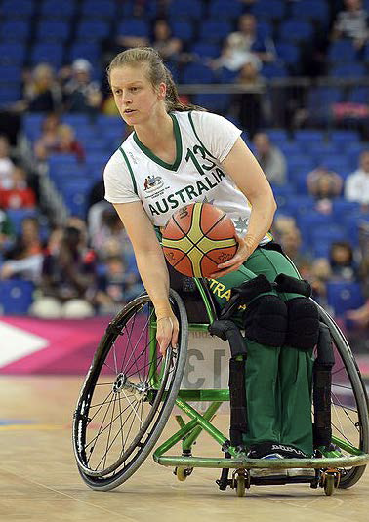

Evaluating progress

Measuring the effectiveness of Diversity, Equity, and Inclusion (DEI) strategies is important to assess progress and identify areas for improvement. While DEI measures can vary based on organisational goals and priorities, here are some common metrics used for evaluating inclusive strategy and implementation.

- Knowledge of diversity, equity, and inclusion concepts among all employees or members and how they relate to sports.
- Representative participation: the identity of people engaged by the organisation reflects the diversity of the population (local, state, national).
- Leadership representation in communications, strategic process, and decision-making.
- Investment in DEI training and education, and adaptation of all learning and development content and activities; and, participation in training.
- Equitable pay for people of diverse identities, and equal pay for equal work.
- Engagement, participation, and satisfaction levels.
- Community Impact through promotion of diversity and inclusion, hosting events, and providing resources.
- Legal compliance with workplace, OH&S and human rights laws
- Policy comprehensiveness and currency

Useful links:

- Check your cognitive biases with this link to a codex.
- Press this link to take some free eLearning courses.

10

Creating an accessible, inclusive document

Image description
Carol Cooke AM, Australian Paracyclist, speeds down the finishing strait on her three wheeled tricycle.

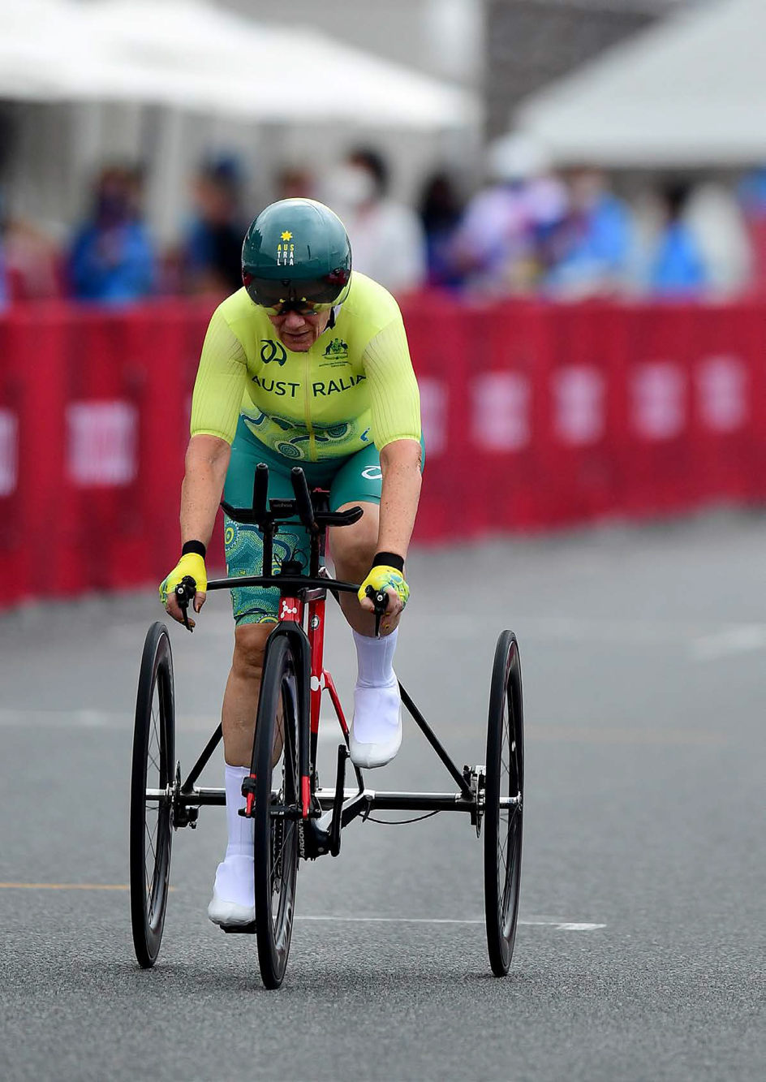

Creating an accessible, inclusive document

An accessible, inclusive document is one that is designed and formatted in a way that ensures it can be easily understood and navigated by a diverse audience, including people with disability.

Creating accessible documents is important for promoting inclusivity and providing equal access to information for everyone. It can also a rewarding creative challenge.

By incorporating accessible principles and practices, documents are more available to a wider audience, which extends their usefulness and impact. It also reduces the likelihood that people will respond asking for changes and support, which means the organisation has more time and resources to work on other activities.

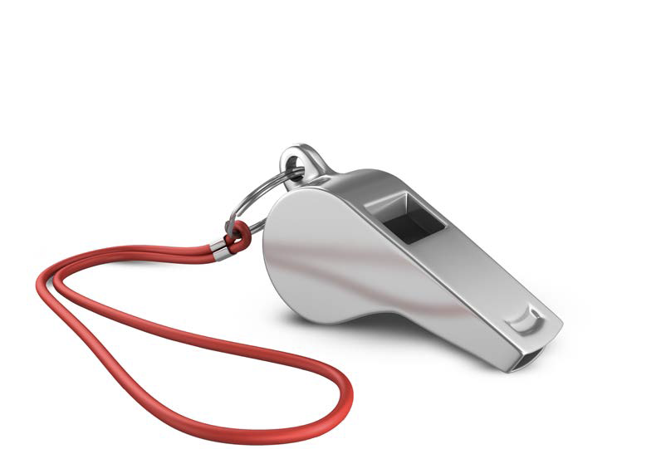

Image description: A sports whistle sits on a white background.

Key considerations for making a document accessible and inclusive.

Adopting the recommendations below will assist all readers of communications and content to find, understand and use the information being provided. They will be universally welcomed.

Text and fonts.
- Use clear and legible fonts.
- Use font size 14pt or above (and 16pt for fonts that are inherently small)
- Avoid using decorative fonts or fonts that may be difficult to read.
- Ensure there is sufficient contrast between text and background colours

Logical structure and descriptive headings.
- Using headings and applying a logical structure helps readers navigate a document.
- Use cascading heading styles to create a hierarchical structure. Make use of heading levels (e.g., Heading 1, Heading 2) to organise content.
- Use descriptive sentences for headings.

Alternative text and descriptive text for images.
- People who have vision impairments use technology such as screen readers to know what is on a page. Text that is part of (designed into) an image, cannot be read.
- Use alternative (‘alt’) text embedded in image files to clearly describe the composition of an image.
- Use descriptive text below an image to describe image in language and text that is valuable for all readers.

Using hyperlinks in sentences and content.
- Use descriptive link text that provides context about the linked content, for example ‘press this link to watch a video about universal design’.
- Avoid generic terms like ‘click here’ or ‘read more’.
- Hyperlink text in or at the end of paragraphs rather than placing them separately, for example in a ‘find out more’ button graphic.

Using colour for backgrounds or text.
- Ensure information is not conveyed or categorised solely through colour.
- Provide sufficient contrast between text and background colours.
- Preference the use of black text on a white background.

Arranging information in tables.
- Because tables may have a logic that expects the reader to read and understand information vertically and horizontally, they can be problematic for screen readers and are best avoided. Use lists instead.
- If tables are used, make them simple and well-structured (for reading horizontally). Provide clear table headers and captions.

Use proper list formats for ordered and unordered lists.
- Clearly introduce bulleted or numbered lists with descriptive text.
- Describe what the list is and whether it is ordered using a particular logic.
- Use proper HTML markup for lists in digital environments.
- Use full sentences for each list item.

Apply clear and concise language and writing style.
- Use clear and concise language in well-structured sentences that guide cognition.
- Define acronyms and abbreviations.
- Consider the purpose and goal of the document when assessing how to inform audiences of different reading abilities.

Prepare documents in accessible formats.
- Save documents in accessible formats using software that checks the level of accessibility (e.g. PDFs with proper tagging).
- Provide alternative document file formats, for example, Microsoft Word and Adobe PDF.

Provide document metadata, including title, language, and author information.
- This information can be added to the file before it is saved and helps different technologies define the document and identify and present information appropriately.

Prepare and placing audio and video content.
- Describe embedded video content in the document.
- If the video is provided via a link, describe where the video is hosted, what it comprises and how long it will run for so reader know what will happen if they press the link.
- Include captions for videos.
- Provide transcripts for audio content.

Using forms and interactive elements.
- Adequately describe the purpose, process, and use of forms.
- Ensure that forms have a navigable logic.
- Include proper labels for form fields.
- Test the accessibility of any interactive elements using technology and user research.

Test your document by getting feedback from its intended readers.
- Different readers will have different requirements. Ask your readers which formats they would like the document to be provided.
- Get feedback from your intended readers before finalising and distributing a document.
- Conduct accessibility testing using tools and assistive technologies.
- Gather feedback from users with diverse abilities to identify areas for improvement.

Useful external links for making a document accessible and inclusive

11

Digital communication and content

Image description
Jessica Cronje, 4.0 point Australian wheelchair basketball player, dodges a defensive player from the other team and prepares to pass.
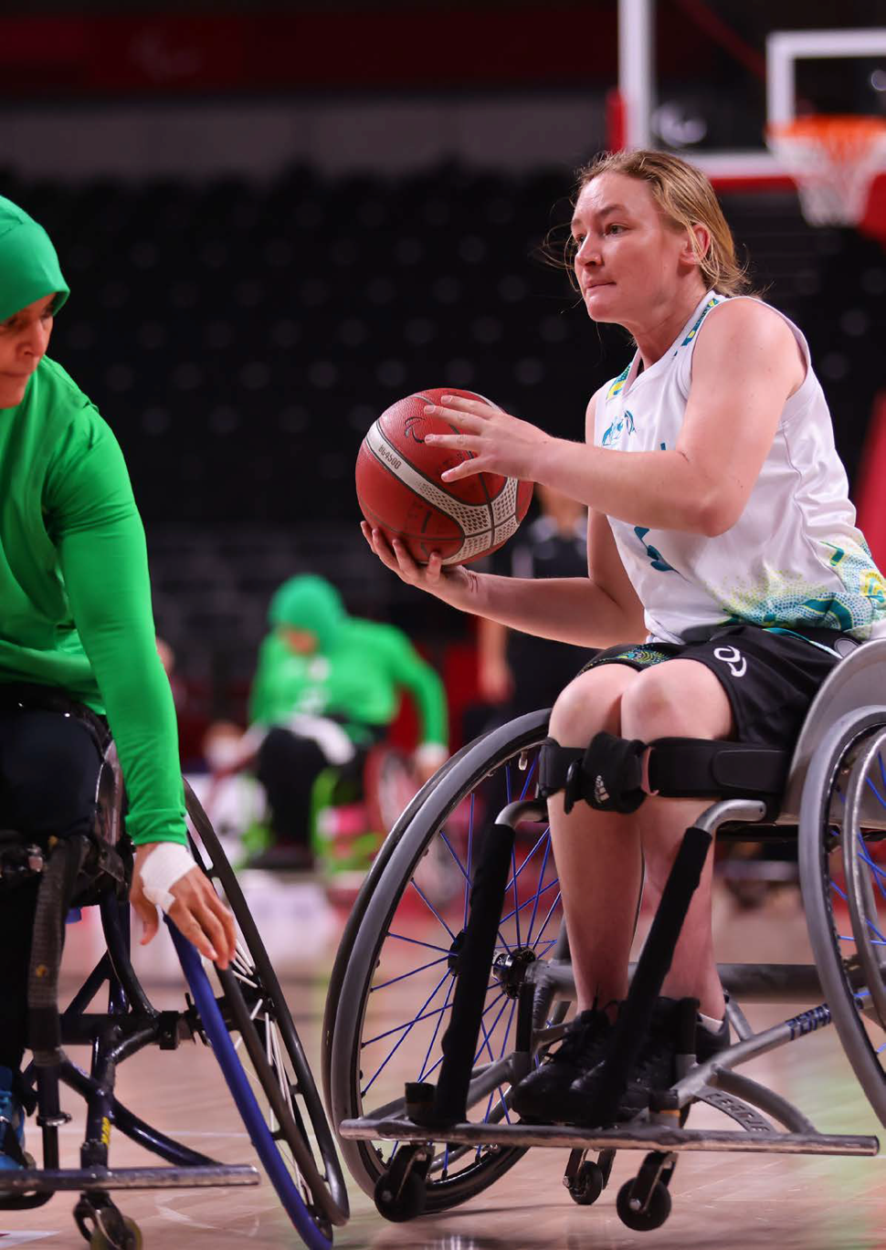

Digital communication and content

Digital platforms have some key advantages for accessible and inclusive communication.

Furthermore, software increasingly includes accessibility check functionality which helps website designers and developers, and content authors, assess and improve content before it is published.

The advantages of digital communication
Digital communication platforms often provide options for customisation and adaptability. Users can adjust settings, such as text size, contrast, and colour schemes to suit their individual needs.

Assistive technologies.
Digital platforms can integrate with a variety of assistive technologies such as screen readers, speech recognition software, and alternative input devices. These technologies help individuals with visual, auditory, or motor impairments to interact effectively with digital content.

Text-based communication.
Many digital communication methods, such as emails, messaging apps, and social media, are primarily text-based. This benefits individuals with hearing impairments or those who rely on screen readers, as they can access information through written text.

Real-time communication.
Features like real-time chat, instant messaging, and video conferencing can facilitate effective communication for individuals with mobility or speech impairments. They may find it easier to express themselves through text or use video calls with sign language interpretation.

Closed captioning and transcription.
Digital platforms often provide features like closed captioning and transcription services, making content accessible to individuals with hearing impairments. This is particularly useful in video content, webinars, and online meetings.

Remote accessibility.
Digital communication enables remote interaction, allowing people to participate in conversations, work, and social activities without the need to travel. This is especially beneficial for people with mobility or transportation challenges.

A range of media.
Digital platforms support a variety of communication modes, including text, audio, video, and images. This flexibility accommodates diverse needs and preferences, allowing individuals to choose a communication medium or channel for that meets their needs and preferences.

Image description: Running shoes sit on a white background.
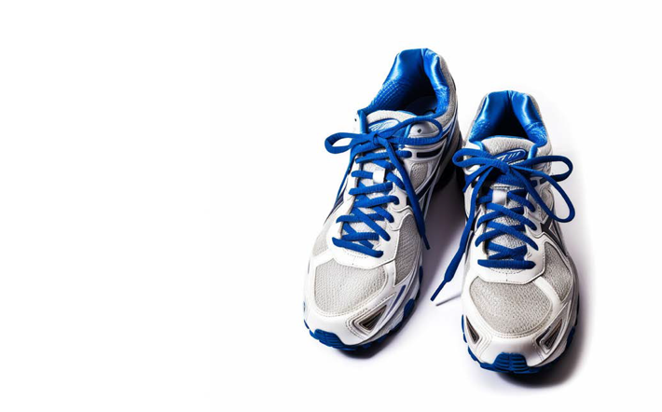

A checklist for assessing if a website or content is accessible.

The New South Wales Government has produced a checklist for helping people make sure digital content and technology is accessible.

- Do your images have alternative text?
Alt text, also known as ‘alt tags’, improves accessibility for screen reader users. Screen readers cannot comprehend images and only read code, so without alt text, the image will be undetectable to the user. Be descriptive when embedding alt text, the more detail the better.

- Have you met colour contrast requirements?
Colour contrast is crucial for individuals with colour blindness or low vision to have a positive web experience. Insufficient contrast can result in a poor experience for these users.

- Are your headings nested and descriptive?
Header tags (e.g., H1, H2, H3) play an important role in organising and breaking up web content. Making it easier for screen readers to navigate through the page utilising non-visual cues to distinguish between content sections easily.

- Is your multimedia accessible?
Videos should have clear synchronised captions to allow users with hearing impairments to understand speech. Audio files must have a transcript. This benefits not only those with hearing impairments but also those who prefer to watch videos in a public space without headphones by allowing them to read subtitles quietly. Our recommendation is to have both closed captioning and a html version of the transcript accessible to cover all bases. Lastly, ensure users can stop multimedia that auto plays.

- If styling was removed is the content in logical order?
To ensure a readable interface, incorporating visual cues to distinguish and group related content is important. This group aids in enhancing readability, particularly for individuals who struggle with reading on-screen content or rely on screen readers. However, while visually grouping content, it’s essential to ensure that the source order is not altered and that the same content reading order is not skewed for individuals using screen readers.

- Do any elements have flashing or blinking?
Flashing lights or bright, blinking elements can trigger seizures in individuals with epilepsy or related conditions. Make sure to keep the brightness, flashes, and blinking to a minimum (less than 3 flashes) to avoid triggering episodes. If unsure, remove it from the page.

- Is the content responsive?
Does the page content resize to a single column with no horizontal and vertical scrolling? Can line height, spacing between paragraphs and letter and word spacing be changed without breaking anything?

- Are your interactive elements operable?
Interactive elements like drop-down menus and clickable images should be accessible through keyboard or voice commands for individuals with motor impairments. There should also be two or more ways to find content such as a search feature, navigation menu or site map. Ensure these elements are functional with assistive devices.

- Is your text easy to read?
To make your site easy to read, use large, left-aligned text with an easy-to-read font when possible. Ensure users can zoom pages up to 200% and still have content be usable. Justified text is more difficult to read because of extra space between the words.

- When a user makes a mistake completing a form or a transaction, are the errors identified?
Ensure clear feedback is provided to the user when completing online forms.

To visit and use other New South Wales government resources use this link.

The Web Content Accessibility Guidelines

The Web Content Accessibility Guidelines (WCAG) provide recommendations for making digital content more accessible to people with disability. WCAG are designed and managed by the Web Accessibility Initiative of the World Wide Web Consortium, also known as W3C. Web inventor Tim Berners-Lee founded the World Wide Web Consortium in 1994 to ensure the long-term growth of the Web.

Visit the Web Content Accessibility Guidelines webpage using this link.

There are four main guiding principles of accessibility upon which the Web Content Accessibility Guidelines has been built. These four principles are known by the acronym POUR for perceivable, operable, understandable, and robust.

- Perceivable: Make sure your product can be perceived by all users, including those with vision or hearing impairments. Key recommendations include providing alternative text for images and captions for videos, using clear and easy-to-read fonts, and providing high contrast colours.
- Operable: Ensure that users can easily navigate and interact with your product using different input methods, such as a keyboard or screen reader. Key recommendations include providing clear and consistent navigation, making sure all interactive elements are accessible via the keyboard, and avoiding content that flashes or blinks rapidly.
- Understandable: Ensure your content is easy to understand for all users, regardless of their cognitive ability. Key recommendations include using plain language, providing clear instructions and error messages, and avoiding jargon or technical terms that might be difficult to understand.
- Robust: Make sure that your product can be accessed using a wide range of assistive technologies, such as screen readers or braille displays. Key recommendations include using HTML markup that is well-structured, providing text transcripts or audio descriptions for multimedia content, and avoiding proprietary technologies that may not be supported by all users.

By following these principles, you can make your digital presence and technology more accessible and inclusive for all users, including those with disabilities.

To find out more about web accessibility, visit this address:
https://www.w3.org/WAI/videos/standards-and-benefits/

12

Tools – Examples in action

mage description
Amelia White representing Australia as a Para-equestrian at the Tokyo Games.

Tools – Examples in action

Example meeting agenda.

The agenda below has been provided as a guide. Sports organisations are encouraged to adapt the structure and content to their needs, using the Paralympics Australia Universal Design Guide for creating Inclusive Sport in Australia for content and to guide discussion.

The agenda is for a 2-hour participatory workshop. Its goals are to:

- Share knowledge and concepts.
- Identify and understand opportunities and barriers to achieving inclusivity.
- Address opportunities and challenges in a creative brainstorm which produces some early ideas for building on after the meeting.
- Establish momentum behind universal design intentions and gain a commitment for ongoing action from participants.

Agenda

1. Welcome and introductions. (10 minutes)

- Welcome participants and thank them for attending.
- Acknowledge Traditional Owners.
- Do a roll call of all participants in the meeting (communicate their names and roles)
- Introduce the purpose of the meeting: learning about the concepts of inclusivity and universal design, and discussing how they can be adopted in our organisation and community.

2. How inclusion feels - an icebreaker activity. (10 minutes)

- Ask participants to form small groups of 2-5 people and to nominate a spokesperson from their group.
- Ask participants to form small groups and discuss a situation in which they were included in a community or activity, how it felt to belong and how that experience impacted them.
- Ask the spokespeople to playback key points from their discussions.

3. Adopting an Inclusive Mindset. (20 minutes)

- Watch the video from Vinnies NSW on an inclusive mindset (https://www.youtube.com/watch?v=HVvH2j06JGU)
- Define and discuss the inclusive mindset.
- Explain the benefits of an inclusive mindset.
- Encourage participants to share personal experiences and any perceived barriers to adopting and practicing an inclusive mindset.

4. The principles and goals of universal design. (15 minutes)

- Introduce the concept of universal design and its principles and goals.
- Discuss how universal design goes beyond physical spaces to include communication, organisation strategy, education, and technology.

Time for a Break (15 minutes)

5. The Hangar.

- A case study of universal design in sport. (15 minutes)
- Share the Paralympics Australia case study about how universal design principle were applied to develop The Hangar training facility with Essendon Football Club.
- Open the floor for questions and reflections.

6. Brainstorming how we might apply universal design. (30 minutes)

- Ask participants to identify inclusion problems to solve at the organisation. These can be policies, communications, physical spaces, digital environments, work practices and employee or leader attitudes.
- Break participants into small groups to brainstorm solutions to the problems. Frame discussion using the universal design goals and principles.
- Encourage creative thinking and collaboration. There are no silly ideas. We are just getting started. Let’s have some fun.
- Ask each table to share their top three ideas with the larger group.

7. Open discussion (10 minutes)

- Summarise key points from the meeting.
- Open the meeting to questions, comments, and additional thoughts.
- Address any concerns.

8. Closing and Next Steps (10 minutes)

- Thank participants for their engagement and contributions.
- Ask who is keen to be involved in a project, with/without organisational support.
- Outline the intended process for using workshop outcomes and when participants can expect to hear more.

Example of an accessible document

Below, an example of an accessible document layout is provided. The example used is networking event for Para Sports.
_

Subject: Join Us for the ParaPower Insights and Networking Virtual Event.

Dear (name),

We are excited to invite you to the first event in our ParaPower Insights and Networking Events series.

1. An overview of the event.

At ParaPower Insights and Networking Events we are joined by Paraathletes who share their valuable experience and welcome questions from participants.

Key highlights of the events include:

- Insightful keynote speeches by industry leaders
- Interactive workshops and peer discussions
- Opportunities for one-on-one Q&A

At the first event, you will hear firsthand from Paralympian, Alex Smith. Representing SuperMart, Alex will share with us their experiences in navigating life’s tightrope by setting goals.

Alex will explain how to set realistic and meaningful goals while maintaining equilibrium with the other aspects of life to ensure success is achieved alongside wellbeing.

This event is not just a gathering of peers, but an opportunity to learn from an industry captain with deep lived experience.

It's also a platform for you to share your experiences, learn from others, and build connections that can help your professional and personal growth.

2. Event details.

The event will be held on the 14th of December 2023, from 1 to 2pm Australian Eastern Standard Time.

It will be an online event, accessible via a Zoom link that will be provided to all participants in a calendar invitation.

The sessions will have live captions as standard and, assuming we have permission from all participants, we will record the session and publish a captioned video recording and transcript of the discussion afterwards.

3. Confirm your attendance.

Please confirm your attendance by emailing Jay Brenner using email address: jbrenner@parapower.org.au

Please let Jay know if you have any accessibility requests.

We are looking forward to your participation and are excited about the potential collaborations and discussions that will emerge from this event.

Hope to see you there!

Examples of a social media post and video, and approaches for digital content creation

Social media posts

Key points to note about accessible social media posts:

- The post image(s) are kept free of text elements.
- Under the narrative post text, an image description is included.
- Image descriptions use clear and accessible language and is clearly labelled.
- The comments fields can be used to build out the post narrative and increase engagement.

The image below is of a social media post optimised for accessibility. The post features:

- An Australian women’s wheelchair basketballer competing, on-court, against an Algerian sportswoman.
- The post text: Australia has a proud history of achievement in International Wheelchair Basketball, looking forward to more gold in Paris! Come on Aussie.
- An image description: Jessica Cronje, 4.0-point Australian wheelchair basketball player takes to the court in the Paralympic Games.

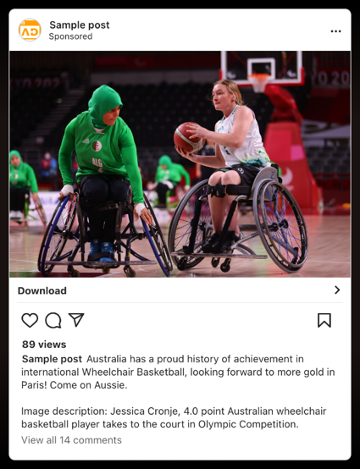

Video

Key points to note about accessible videos:

- Captions should be uploaded with the video as an SRT file (plain text files which include the text of the subtitles in sequence, along with the start and end timecodes)
- In this example captions are also ‘burned in’ to the frame.
- Audio Description enhanced soundtrack can be uploaded with any YouTube video.

The image below links to an accessible YouTube video. The image features three Paralympians wearing their green and gold uniform and standing in the stands of stadium. Each is smiling and holding a copy of the Paralympics Australia document, titled Imagine.

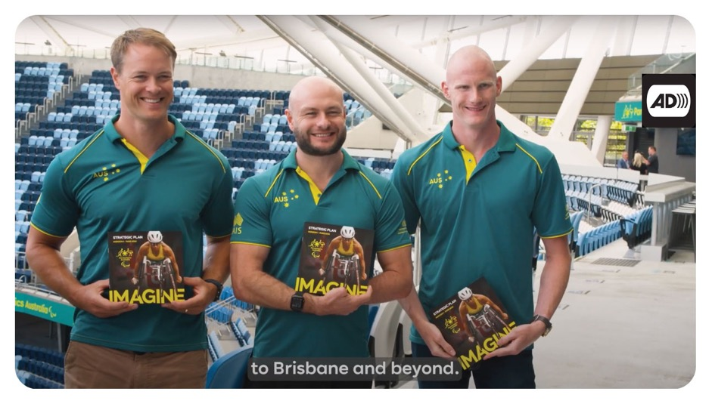

13

Resources

‘

Resources

The following resources are available online from leading organisations. At the date this guide was published, all hyperlinks were functional.

Leading organisations

Centre for Universal Design Australia
https://universaldesignaustralia.net.au/

Australian Human Rights Commission
https://humanrights.gov.au/our-work/disability-rights

Centre for Excellence in Universal Design (Ireland)
https://universaldesign.ie/

Centre for Universal Design and Environmental Access,
University of Buffalo (United States)
https://idea.ap.buffalo.edu/

DO-IT Centre, University of Washington (United States)
https://www.washington.edu/doit/resources

Resources

Australian Sports Commission activity relating to diversity in sports
https://www.sportaus.gov.au/integrity_in_sport/inclusive-sport/understanding-our-diverse-audiences

Australia’s Disability Strategy Hub
https://www.disabilitygateway.gov.au/ads

Australia’s commitment to the United Nations Convention on the Rights of Persons with Disabilities (UNCRPD)
https://humanrights.gov.au/our-work/disability-rights/united-nations-convention-rights-persons-disabilities-uncrpd

Whole of Victorian Government Universal Design Policy Summary
https://providers.dffh.vic.gov.au/universal-design-policy-summary

Communications Toolkit for Services to the Public – A Universal Design Approach, Centre for Excellence in Universal Design

https://universaldesign.ie/communications-digital/customercommunications-toolkit-a-universal-design-approach

Inclusive Design Principles for digital design
https://inclusivedesignprinciples.org/

People with Disability Australia, Accessibility Action Plan Template
https://pwd.org.au/wp-content/uploads/2019/09/Creating-Access-Accessibility-Action-Plan-template-WEB-and-PDF.pdf

IncludeAbility. Human Rights Commission Resource Hub
https://includeability.gov.au/

Australian Human Rights Commission free online learning resources
https://humanrights.gov.au/education/training/free-elearning-courses

Centre for Inclusive Design
Writing in Easy English vs Plain English
https://centreforinclusivedesign.org.au/wp-content/uploads/2020/04/Easy-English-vs-Plain-English_accessible.pdf

Digital accessibility and inclusion (MS, Adobe, Google)

Microsoft Inclusive Design hub
https://inclusive.microsoft.design/

Adobe Inclusive design learning resources and tools
https://adobe.design/stories/leading-design/adobe-inclusive-designworkshop

Google guide to captioning YouTube videos
https://support.google.com/youtube/answer/2734796

Auslan Services

Expression Australia
https://interpreting.expression.com.au/

National Auslan Interpreter Booking & Payment Service
https://www.nabs.org.au/

Join us

Join the community of practice.

Paralympics Australia will be testing and refining this guide with people across the country. We welcome input on where and how we can improve.

We are always keen to hear from people who have succeeded in inclusive universal design in their sports club or sports organisation. Get in touch!

And, if you are keen to stay informed as we roll out new programs, let us know.

Contact Paralympics Australia’s Universal Design Team:
Sarah.Stewart@paralympic.org.au

[End of document]

